Networking for Software Developers

This is a group lab that will contribute towards your final project. One person will submit this work to the group dropbox in the course shell.

# Lab 12 – Display a Dynamic Line Chart.

You will display a line chart of a dynamic dataset. It is advised that you start with lab 11 and add the capability to update the display You will add the capability of dynamically display a change dataset. We will build a GUI to display a set of values. You will display the values using both a line chart and a bar chart on the same app. Most of the coding will come from Week_10_lab_11_DisplayChart.docx. You will make the following addition to your solution of lab11:

1. Create an additional method that will be executed in a thread. This method will do the following in an infinite loop:
   * Remove the first item in the list of values
   * Add a new random value to the end of the list
   * Call the method to display list on the canvas
   * Sleep for a short while (0.5 of a second).
2. In the initUI() method do the following at the end:
   * You may remove the Entry widget. This is not used in this application.
   * Create a thread and set the target to the method in step 1
   * Set the daemon property of the above thread to True. This will terminate the thread when the Gui closes.
   * Start the thread.
3. Modify the method that draws the rectangle and line to just draw lines.

## Due:

Before the start of week 11

#### Submission

1. Your code file will be named group_«your_group_number»_dynamic_chart.py e.g. group_1_dynamic_chart.py.
2. Must be uploaded to course dropbox.
3. 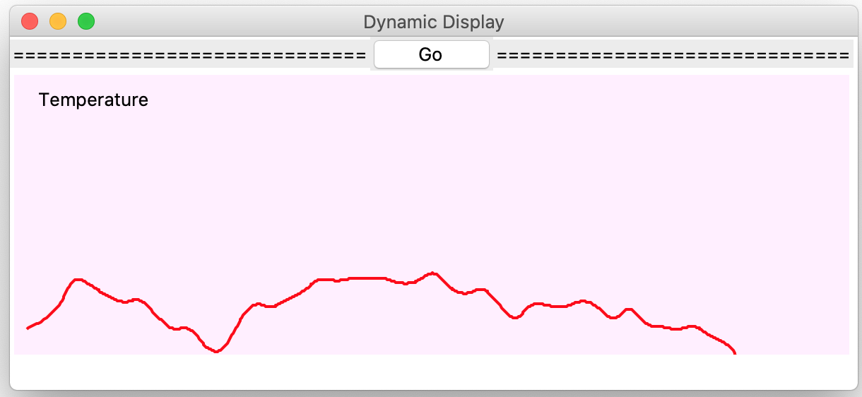This is due by the end of week 11.

#### Rubrics

|  |
| --- |
| Marks breakdown |
| [reasonable class design] - init method, task broken down logically 3/4 |
| [code readability] - pythonic names for variables and methods 3/3 |
| [initUIb method] - initialize the ui 3/3 |
| [use generator] - 1/1 |
| [thread method] - mut run the updateGUI method is a thread 6/6 |
| [update Gui] - remove existing line and draw new ones 8/8 |
| [gui] - proper title, legend, ticks on axis 3/3 |
| [aesthetics] 3/3 |
| [Deductions] - bad programming practices 0 |
| [Total] 30/30 |